The project compromises of a significant part of software work, apart from the hardware. The project derives its innovative component from the tricky software that we have developed. In a nutshell we have used the same hardware of the existing RFID technology, modified it a bit using analogue components (for signal amplification) and developed software algorithms that can control it as per our idea.

The software that we have developed was quite crucial and big, so adequate planning and analysis was required in terms of formal frameworks of software engineering. So we started the planning phase right from the beginning, parallel to antennae range research. We tried to make the complete software as per plan but the scope and size of the application was too large and would require much more time and labour than provided in this competition. However we finally realised that for such large projects spiral model of software development is used, which is designed in incremental versions. The software that we have developed so far is just a prototype of our planned final release. This method was adopted to demonstrate and depict our idea in the minimum possible time. In the following sections we have included some elements of the planning, analysis, requirement gathering and development phase of the software.

## 

## Overall Description of software

### Product Perspective

The major concern of ‘Smart Library Management System’ is the ‘management of question papers’ in our Nava Nalanda Central library of Thapar university, Patiala. This must be of major concern to any university or organisation, as this is the part of ‘knowledge management’, which is very crucial to any organisation. Because already a semi-automatic system exist, care has been taken the proposed system is compatible with the existing infrastructure so minimal change is required to update the present system to our fully automatic solution.

### Product Features

1. For Users
   1. Search a book using various options like title/ authors/ publishers/ etc
   2. Issue a book on-the-fly
   3. Return the book on-the-fly
   4. Display the reviews of the book issued.
2. For Administrator
   1. Add book to database
   2. Change/ edit the details of an existing book
   3. Manage other library managers
   4. Manage sensors
   5. Manage Users
   6. Manage security systems
   7. Manage navigation systems.

### **Project** Scope

Smart library management system” is designed to fit in the existing infrastructure of the existing library. The overall solution and software has been designed to minimise changes to be made to existing infrastructure. In libraries where existing RFID system is implemented, the changes required is even less. The solution proposes to install new RFID sensors in the existing racks without any problem. It will include participation ranging from faculty, library staff and students. These ‘actors’ will have different access rights according to their roles, so that coordination can be achieved and knowledge maintained without any hassle.

### Operating Environment

The current product can run in any system having a basic platform to run Microsoft Windows and VB/ VC++ runtime environment. Same computer has been used in the prototype as the database server however a separate system can be deployed as a database server, depending on load of the server. The separate machine for database will also facilitate a distributed design which will ease the process of taking backups/ ensuring enough redundancy and security.

However the product can be modified to run in a webserver, supporting PHP scripting and a database management system like MySQL. The servers should provide a robust and fast environment for the product. It should cater the needs of its many users both faculty and users and support parallel access without any lag and avoid downtime.

These possible features are required in the webserver where the product is supposed to be hosted

* Servers with Top Line Hardware specs.
* Dedicated MySQL server to handle SQL Queries load.
* Remote weekly backups of server’s data for safety of data.

## System Features

### Search a book

#### Description and priority

This is used to search a book using its various details. The details can include the various parameters as follows. Various security and data integrity features has been embedded to maintain the correctness of data being entered.

* Name of Book
* Authors
* Publisher
* Semester of question paper
* Faculty coordinator
* Code of Subject

#### Stimulus/Response Sequences

The server will receive data from the form based interface and will execute an SELECT query for searching through the database. The results are displayed in the list box.

#### Screenshot

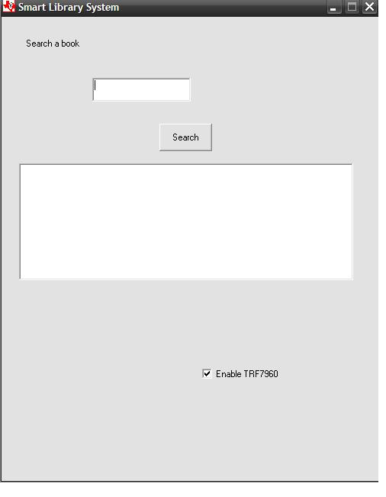

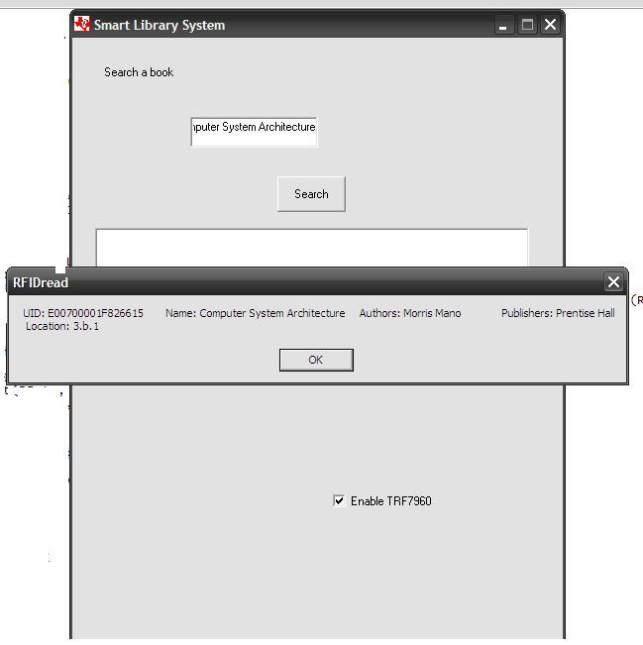

### Issue Book on-the-fly

#### Description and priority

As per our proposed innovative solution, the user has the provision to issue the book right on the shelf as soon as he picks up the book.

#### Stimulus/Response Sequences

As per the protocol, the system will require the user to identify himself/ herself by showing his card in front of the RFID sensor. Once the user gets identified he can see the following image on the screen depicting that system has identified the user and has granted him access.

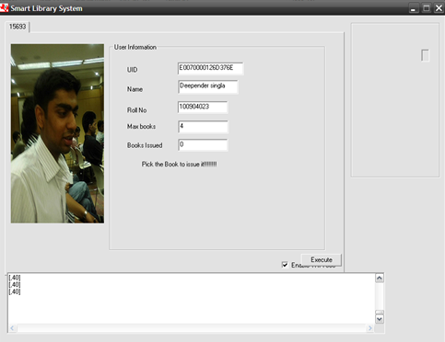

Having granted the access, the user can pick any book from the rack and the system issues it instantly to the specified user. This action can be confirmed with the following image on the screen.

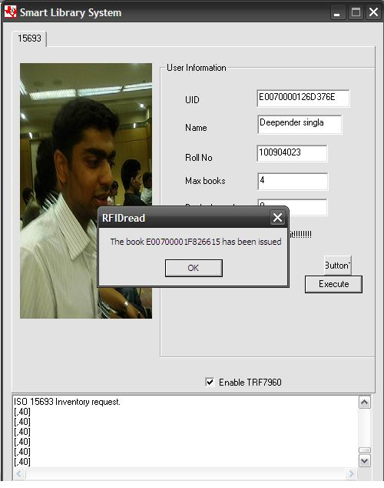

As soon as the book gets issued, the system automatically INSERT INTO the *issue_history* database the entry of the transaction for security and validation. This entry can later be viewed by administrator for various details.

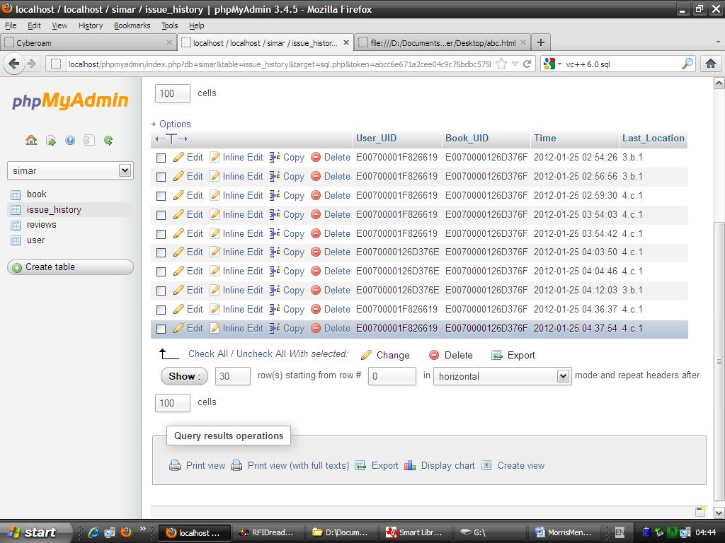

Following which the user database is updated to change bi (number of books issued).

### Return the book on-the-fly

#### Description and priority

Just as in the case of issuing the book, returning the book is even simpler. The user will just come and place the book on the rack. The system (RFID sensors) will detect the book and will de-issue them, the system will calculate fine and will update the database accordingly.

#### Stimulus/Response Sequences

Now the interesting point here is that the system, even if the user does not place the book at its right place, the system will update the new location of the book and keep a track on the book. So any new user who comes for searching the book in the library will get its new updated location and will be able to locate the book very easily.

#### Screenshot

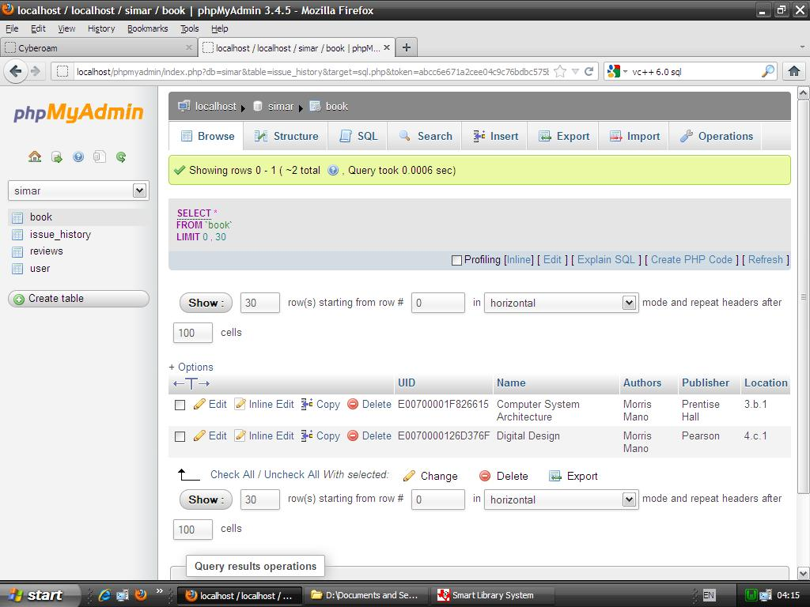

The new location of the book Digital Design is updated in database, as soon as the user places the book in the 4.c.1 rack.

### Displaying reviews

#### Description and priority

#### Screenshot

## 

## External Interface Requirements

### User Interfaces

The main page of product will contain user interfaces for

* Searching a question paper
* Logging on to backend

### Hardware Interfaces

The server running software and maintaining database is required to run the product properly. The server should have sufficient hardware resources like primary memory, secondary memory to satisfy the needs of the server software and the database. Because the project is based on distributed model, the server should be equipped with a network interface from which it should be able to communicate using TCP/IP within the LAN/ WAN. Just as in case the system keeping track of RFID sensors communicate with the security admin’s computer in case, if any user picks up a book without authenticating himself with the system.

## Other Nonfunctional Requirements

### Performance Requirements

1. The product should handle the various requests from different users trying to download question papers all at once.
2. These product should be intelligent and robust to handle parallel accesses should be properly handled by the product so that it can withstand without failing or generating unnecessary lag.
3. The product should deliver its services without any downtime and should have self-recovery functionality.

### Security considerations

Because library is essentially a public service system, security and integrity is a primary requirement for the proper working and implementation of any automation system inside the library. The system in the proposed solution immediately report of any such incident of book theft, if a user picks up a book before getting identified by the system and the alarm and various security cameras will automatically capture the incident.

### C:\Users\Gursimar\Desktop\screenshots\theftalarm.JPG

When the user gets himself identified, the system will issue the book the very instant, when he picks books. Now the book belongs to the user, so its his responsibility. Thus the new system is not only much easier, cheaper but has features of added security as well.

### Software Quality Attributes

* Interoperability
* Maintainability
* Portability
* Reliability
* reusability

## Pseudo code

## UML DIAGRAMS

## Use case diagram

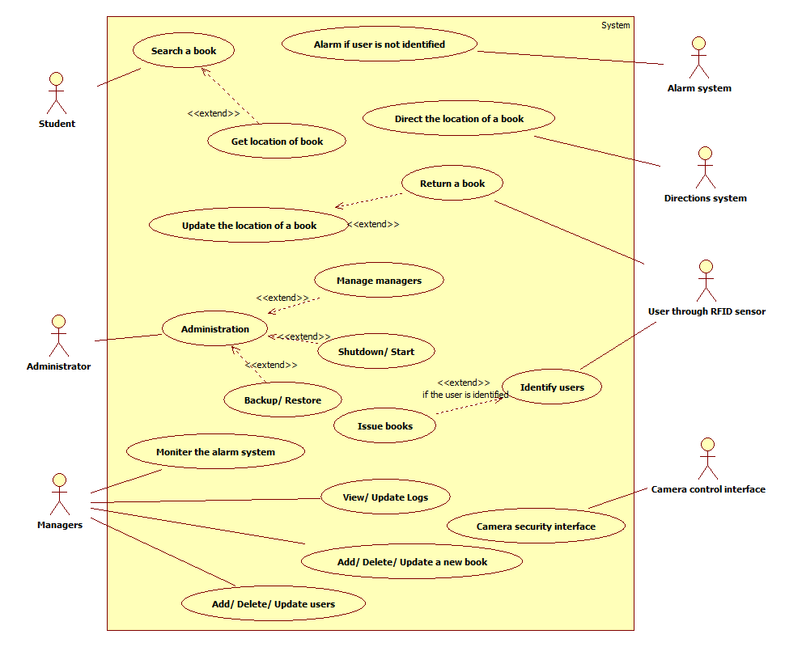

### Activity Diagram

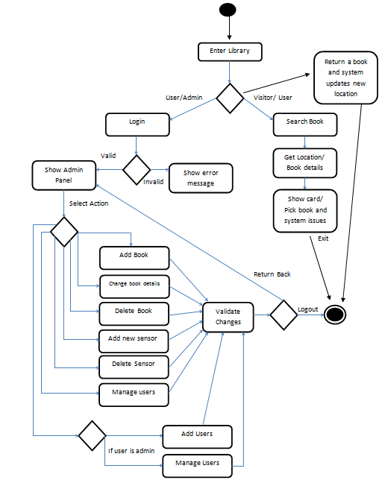

### Context Free diagram

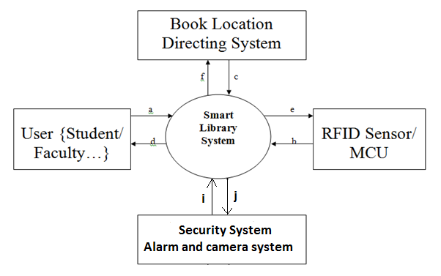

## State machine diagram (some main objects)

### RFID Object

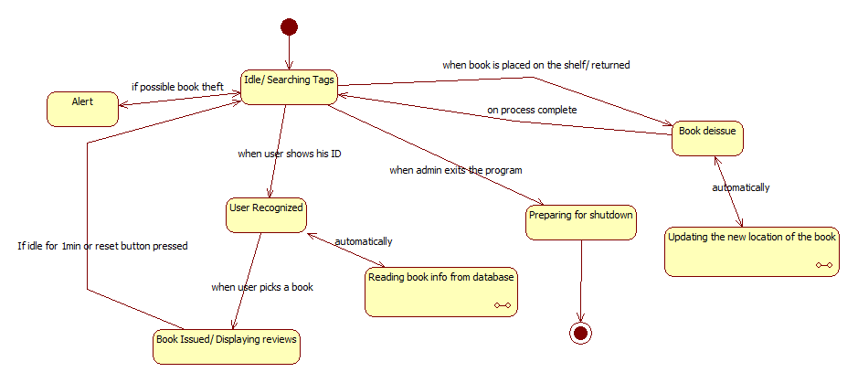

### Search Object

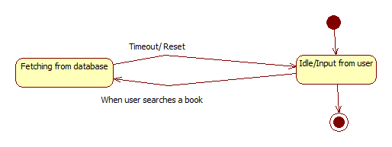

## Class diagram

